**Task 1**

* To recover the affine transformation first I gathered the correspondences to create a graphical interface by asking user to click a point in one image and then asking to click for the same point in second image by using **matplotlib.pyplot.ginput** function.
* From this correspondence I solve for the Affine Transformation by using pseudo inverse
* Then I use recovered ***T*** to warp ***image 2 into*** ***image 1 using*** cv2.warpAffine() function.
* Then I calculated the square error (MSE) to check whether the recovery is good or not.

I repeated this process for three pair of images given in task 1. The results for each image are as fellow.

**For Image 1 (Arfa Tower)**

Given algorithm will work only for same channel images. So first convert the **arfa1** image in gray scale image. Then after applying above algorithm the results are as fellow.

The mean squared error of pixels of T_image and Image2 is

73.81052788445105

The mean squared error of correspondence points and transformed points

93.21311082457184

Recovered transformation

[[ 0.73676175 0.74090297 -150.95000613]

[ -0.73793837 0.73912085 142.12778479]]

Transformed image

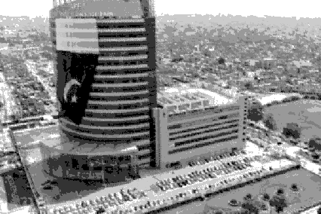

**For Image 2 (Mecca)**

The mean squared error of pixels of T_image and Image2

39.00289830980488

The mean squared error of correspondence points and transformed points

51.163134615384614

Recovered transformation

[[ -0.56068625 0.77216995 70.70576729]

[ -0.74436361 -0.52804116 353.56997118]]

Transformed image

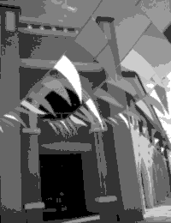

**For Image 3 (Station)**

The mean squared error of pixels of T_image and Image2

2.9783912865724855

The mean squared error of correspondence points and transformed points

0.11049975

Recovered transformation

[[ 0.9246538 0.36005263 -45.46732088]

[ -0.32657774 0.9690714 87.01547794]]

Transformed image

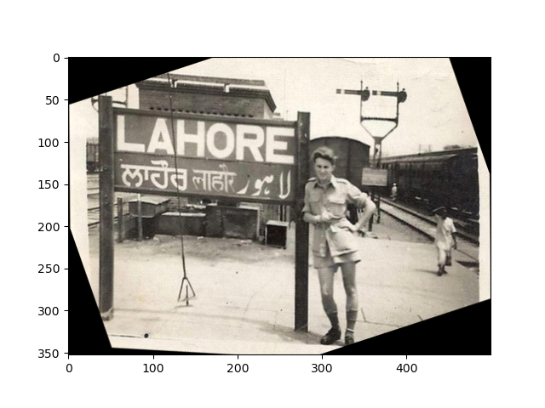

**Task 2**

**For Image 1 (Badshahi)**

The mean squared error of pixels of T_image and Image2

149.00923719388496

The mean squared error of correspondence points and transformed points

99.41501492430261

Recovered transformation

[[ 1.69874733e+00 -6.96535396e-03 2.00846995e+02]

[-8.54489028e-03 1.05650270e+00 5.07760472e+01]]

Registered image

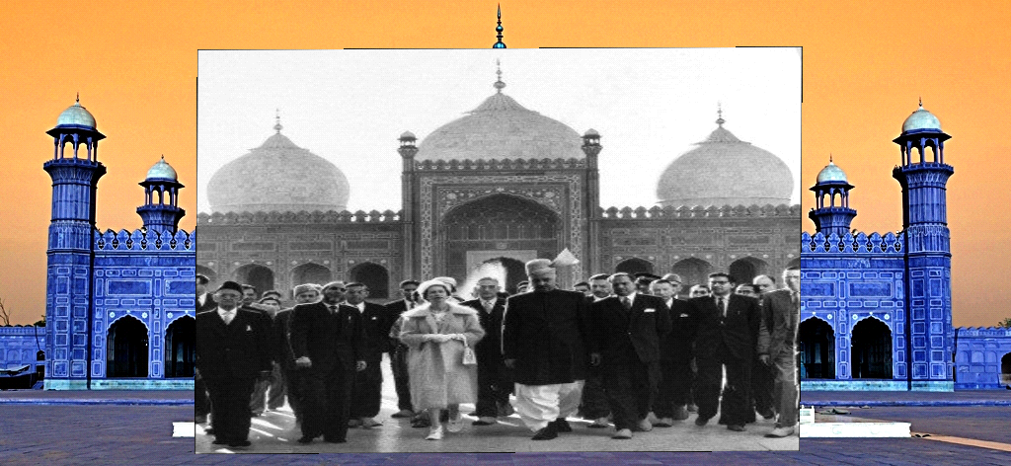

**For Image 2 (Badshahi)**

The mean squared error of pixels of T_image and Image2

112.81747043278592

The mean squared error of correspondence points and transformed points

0.07599986

Recovered transformation

[[ 1.26928371e+00 -1.55410474e-02 3.81837918e+01]

[ 3.84098987e-02 1.14728190e+00 5.00825594e+02]]

Registered image

**For Image 2 (Badshahi)**

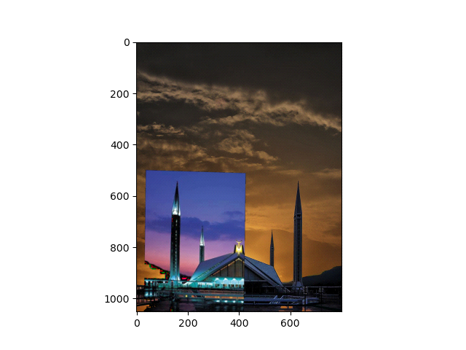

**For Image 3 (Qabil)**

The mean squared error of pixels of T_image and Image2

0.7669438667126364

The mean squared error of correspondence points and transformed points

109.39232533333333

Recovered transformation

[[7.41265680e-01 1.24032105e-02 1.56571145e+02]

[3.98296911e-02 7.48334762e-01 1.14374586e+02]]

Registered Image

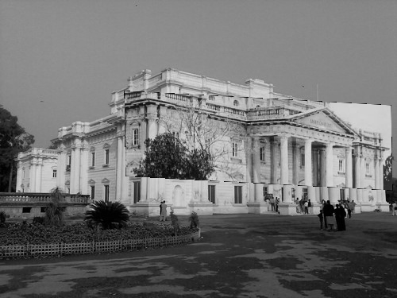

**Task 3**

**Results**

**Set 1**

Stitched image of two images with all matches between

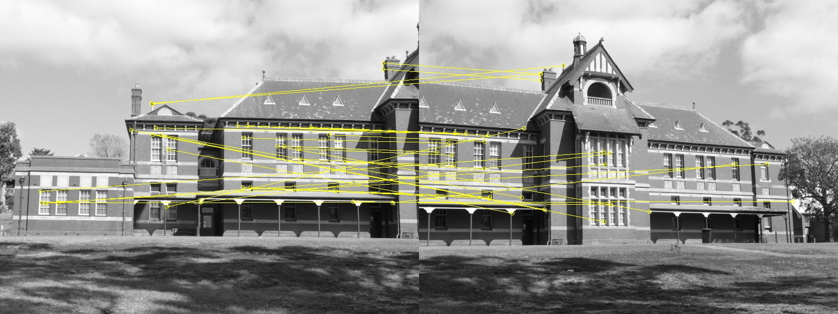

Panorama image obtained after stitching all images

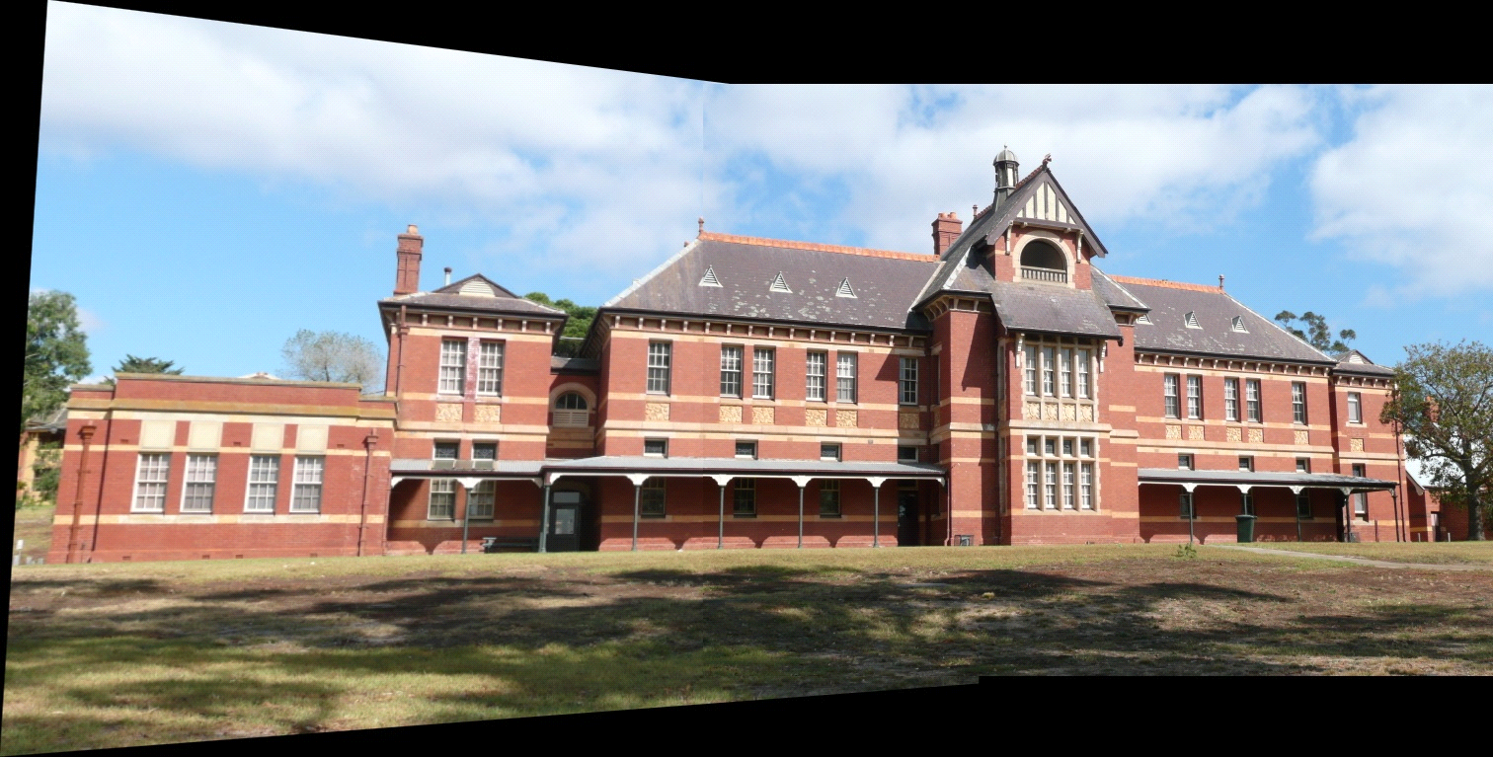

**Set 2**

Stitched image of two images with all matches between

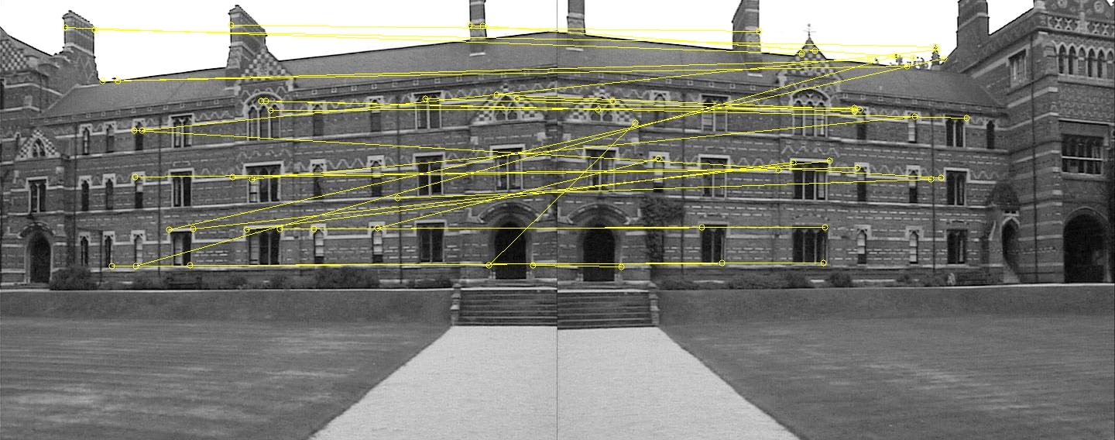

Panorama image obtained after stitching all images

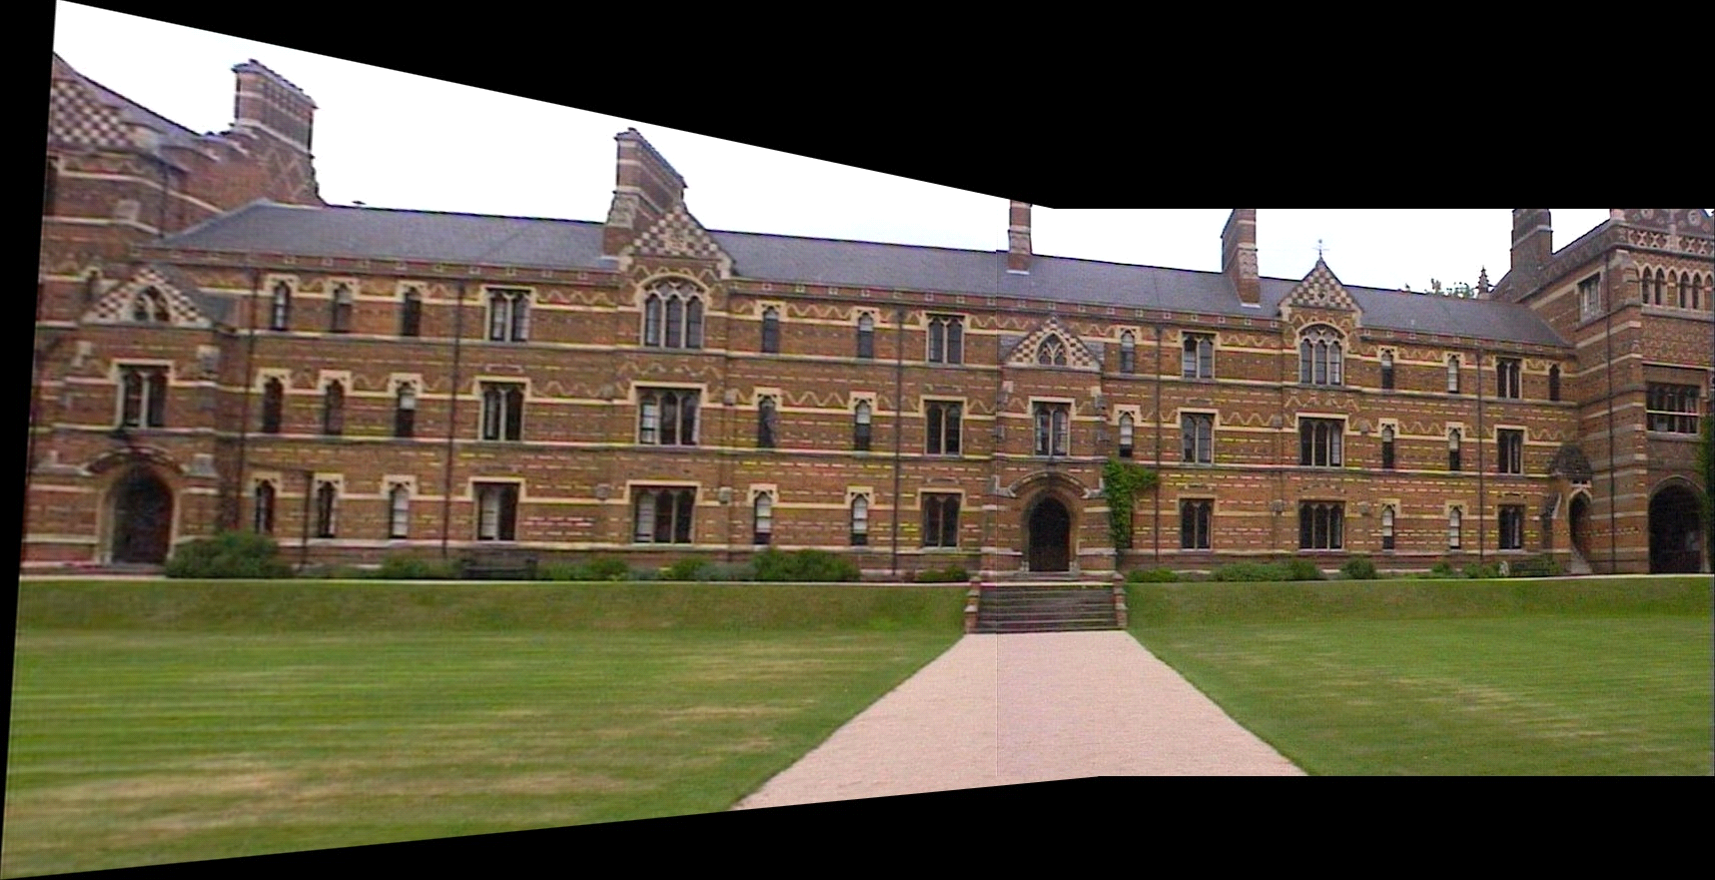

**Set 3**

Stitched image of two images with all matches between

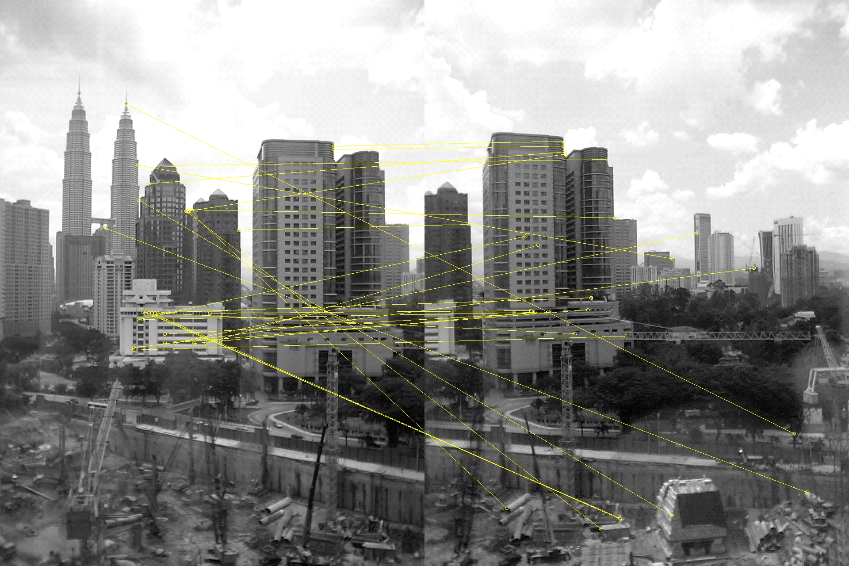

Panorama image obtained after stitching all images

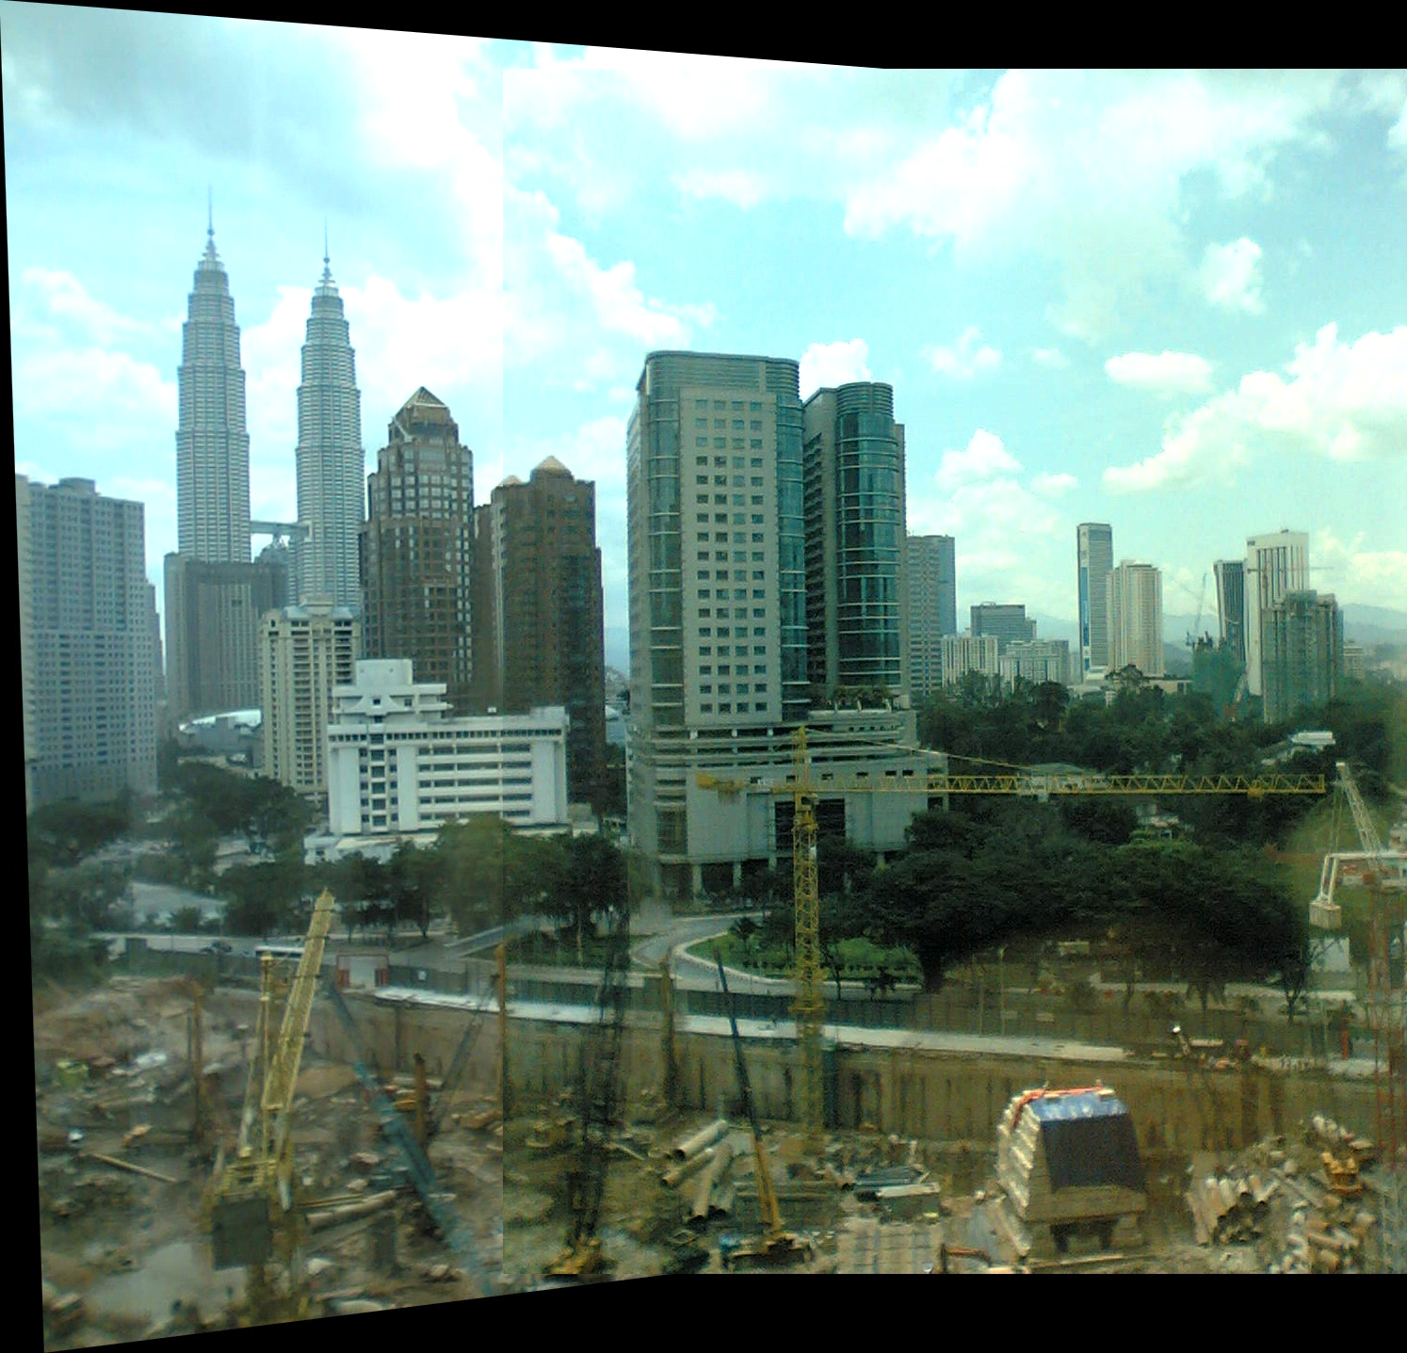

**Set 4**

Stitched image of two images with all matches between

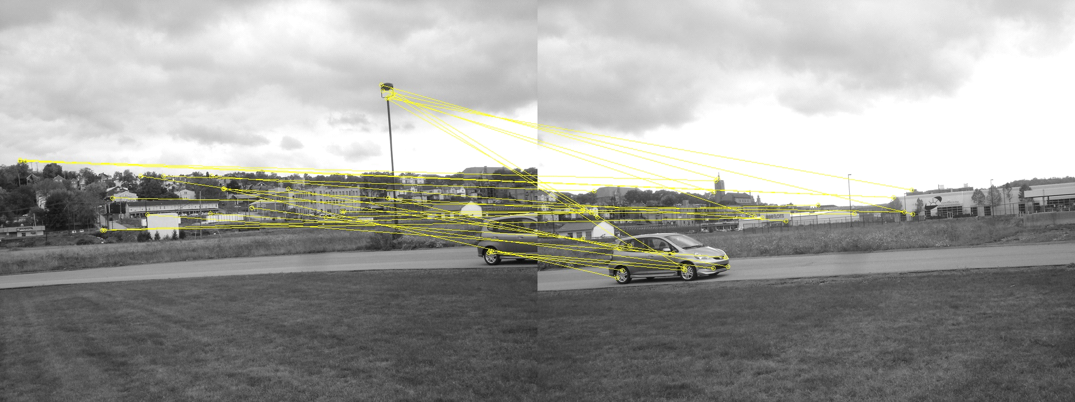

Panorama image obtained after stitching all images

